SMT.TANUBHAI & DR. MANUBHAI TRIVEDI COLLEGE OF

INFORMATION SCIENCE (B.C.A)

AFFILIATED TO

VEER NARMAD SOUTH GUJARAT UNIVERSITY,

SURAT

PROJECT REPORT

ON

“**NOTE SHARING**”



AS A PARTIAL REQUIREMENT FOR THE DEGREE

OF

BACHELOR OF COMPUTER APPLICATION

(B.C.A)

Academic Year: 2023 – 2024

INTERNAL GUIDE: PROF. BHAUTIKA PATEL SUBMITTED BY: BENDRE PRATIKSHA

INDEX

|  |  |  |
| --- | --- | --- |
| **Sr.no** | **Topic** | **Page no** |
| **1.** | Project introduction | 3 |
| **2.** | Scope of project | 4 |
| **3.** | Objective of project | 5 |
| **4.** | Tools and technologies | 6-7 |
| **5.** | * Software Requirement * Hardware Components | 8 |
| **6.** | Use case Diagrams   * 1. Admin   2. Faculty   3. Student | 9-11 |
| **7.** | User Roles | 12-13 |
| **8.** | Table Structure | 14-16 |
| **9.** | Modules and its Functionalities | 17 |
| **10.** | Screenshots | 18-31 |
| **11.** | Future Enhancement of the System | 32 |

PROJECT INTRODUCTION

**Project Title: -** NoteSwap

**Project Description: -**

Welcome to the introduction of our exciting project: a simple note sharing website. Our note sharing website aims to provide a seamless and user-friendly platform for individuals to create, organize, and share their notes effortlessly.

The primary objective of this project is to create a space where users can easily manage their digital notes, making the process of note-taking more convenient and accessible.

SCOPE

* The scope of our simple note sharing website is to develop and deploy a user-friendly platform that allows teachers to upload, store, organize, and share their notes effortlessly and students to store and organize .
* The website will serve as a centralized hub for teachers and students to collaborate, exchange knowledge, and enhance productivity through efficient note sharing capabilities.

OBJECTIVES

* The primary objective of our note sharing website is to provide a seamless and intuitive platform for students and teachers to manage their notes effectively and collaborate with others.
* The system should be more secure for management user notes and more reliable to work at any conditions.
* The system should have records of students and faculty that can be access to the system which can be used only for the authorized person.
* Being an integrated social networking site it should reduce paper work.

TOOLS & TECHNOLOGY

**Front-End:**

**·HTML**- HTML stands for HyperTextMarkup Language. It is a markup language used to create web pages. HTML describes the structure of a web page by using tags and attributes. Tags are keywords enclosed in angle brackets (<>). Attributes provide additional information about the tag.

**·CSS** - CSS stands for Cascading Style Sheets. It is a style sheet language used to describe the presentation of web pages. CSS describes how HTML elements are to be displayed on screen, paper, or in other media.

CSS is a powerful tool that can be used to create visually appealing and functional web pages. It is used in conjunction with HTML to create the look and feel of a web page.

**·BOOTSTRAP5 -** Bootstrap is a free and open-source front-end framework for developing websites and web applications. It is a collection of HTML, CSS, and javascript code that can be used to create responsive, mobile-first websites. Bootstrap is a powerful tool that can be used to create beautiful and functional websites

**·AOI PLUGIN** - AOI stands for Automatic Object Identification. An AOI plugin is a software add-on that can be used to automate the identification of objects in images. This can be useful for a variety of tasks, such as quality control, inspection, and machine vision.

**Back-End:**

**·PHP** - PHP is a general-purpose scripting language geared towards web development. It was originally created by Danish-Canadian programmer RasmusLerdorf in 1993 and released in 1995. The PHP reference implementation is now produced by the PHP Group.PHP is a server-side scripting language, which means that the code is executed on the server before being sent to the client. This makes PHP ideal for creating dynamic web pages that can interact with databases and other server-side resources.

**· MYSQL** - MySQL is an open-source relational database management system (RDBMS). It is one of the most popular databases in the world, and is used by a wide variety of websites and applications.MySQL is a server-based database, which means that it runs on a server and is accessed by clients. The server is responsible for storing and retrieving data from the database, while the clients are responsible for interacting with the data.MySQL uses Structured Query Language (SQL) to interact with the database. SQL is a standard language for querying and manipulating databases.MySQL is a powerful and versatile database that can be used for a wide variety of applications. It is a good choice for websites, applications, and other systems that need to store and manage large amounts of data.

SOFTWARE REQUIREMENT

|  |
| --- |
| * + Windows 10 |
| * + XAMPP |
| * + Visual Studio Code |

HARDWARE COMPONENTS

|  |
| --- |
| * + Processor – i5 |
| * + Hard Disk – 8 GB |
| * + Memory – 256GB SSD |

USECASE DIAGRAMS

* + Admin

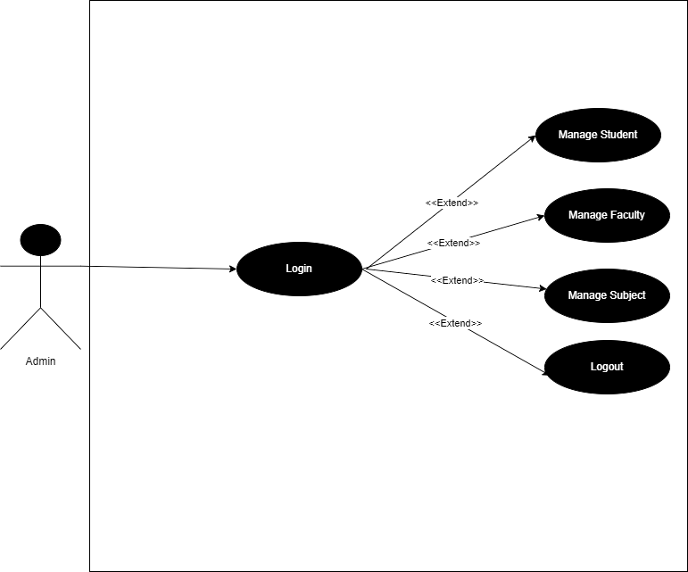

* + Faculty

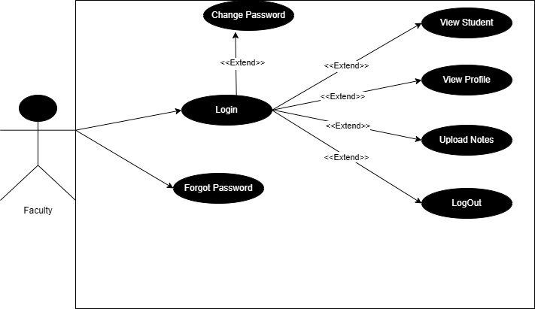

* + Student

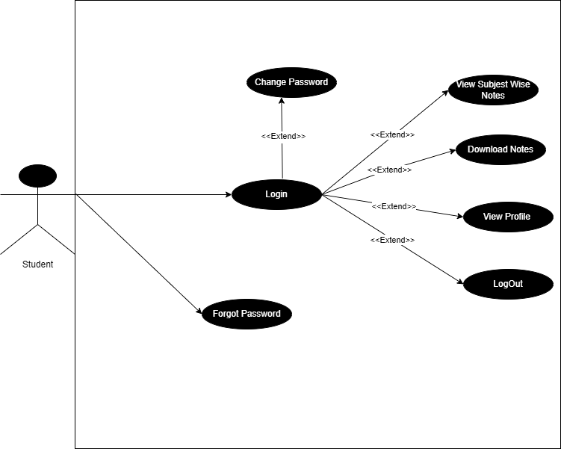

USER ROLES

**1. Admin Role :-**

-Manage Student

-Manage Faculty

-Manage Subject

-Log in

-Log Out

**2. Faculty Role :-**

-View Students

-Upload Notes

-Change Password

-View Profile

-Log in

-Log Out

-Forget Password

**3. Student Role :-**

-Login

-Download Notes

-Change Password

-View Profile

-Subject-wise view notes

-Forget Password

-Logout

TABLE STRUCTURE

**tblnotes:-**

|  |  |  |
| --- | --- | --- |
| Fields | Data Type | Constrains |
| Sr.no | integer(30) | Primary Key |
| Uploaded By (Name) | varchar(100) | NotNull |
| Uploaded on (Date) | date(100) | NotNull |
| Subject | varchar(100) | NotNull |
| Download Notes | varchar(100) | NotNull |
| File Type | varchar(100) | NotNull |
| Description | varchar(100) | NotNull |

**tblsubject:-**

|  |  |  |
| --- | --- | --- |
| Fields | Data Type | Constrains |
| id | integer(30) | Primary Key |
| subjectname | varchar(100) | NotNull |

**tblstudent:-**

|  |  |  |
| --- | --- | --- |
| Fields | Data Type | Constrains |
| id | Integer(30) | Primary Key |
| regno | Varchar(100) | NotNull |
| stud_name | varchar(100) | NotNull |
| stud_phone | varchar(100) | NotNull |
| stud _email | varchar(100) | NotNull |
| stud_address | varchar(100) | NotNull |
| stud _username | varchar(100) | NotNull |
| stud _password | varchar(100) | NotNull |
| stud _gender | varchar(30) | NotNull |
| stud _image | varchar(100) | NotNull |
| resettoken | varchar(100) | Null |
| resettokenexpire | varchar(100) | Null |

**tbladmin:-**

|  |  |  |
| --- | --- | --- |
| Fields | Data Type | Constrains |
| id | Integer(30) | Primary Key |
| username | Varchar(100) | NotNull |
| password | Varchar(100) | NotNull |

**tblfaculty:-**

|  |  |  |
| --- | --- | --- |
| Fields | Data Type | Constrains |
| id | Integer(30) | Primary Key |
| regno | Varchar(100) | NotNull |
| fac_name | varchar(100) | NotNull |
| fac_phone | varchar(100) | NotNull |
| fac_email | varchar(100) | NotNull |
| fac_address | varchar(100) | NotNull |
| fac_username | varchar(100) | NotNull |
| fac_password | varchar(100) | NotNull |
| fac_gender | varchar(30) | NotNull |
| fac_image | varchar(100) | NotNull |
| resettoken | varchar(100) | Null |
| resettokenexpire | varchar(100) | Null |

MODULES AND ITS FUNCTIONALITIES

1. User Registration and Authentication:

* Admin will be able to register accounts for students and teachers and they can log in securely to access the website's features.
* Provides authentication mechanisms to ensure access to user accounts.
* Enables users to login and logout of their accounts.

1. Note Sharing and Collaboration:

* Teachers will have the option to share their notes with other registered users.

1. View Notes:

* Students will have the ability to view notes subject-wise by clicking on the subject.

1. Accessibility:

* The website will be responsive and accessible across multiple devices, including desktops, tablets, and smartphones.

1. Reporting:

* Reporting functionalities, such as exporting notes in different formats (e.g., PDF, Word).

6. Services Module:

* Allows users to import and export notes to and from external applications or file formats.

7.Search:

* Admin will be able to search students and faculty based on registration number.

SCREENSHOTS

* Admin:

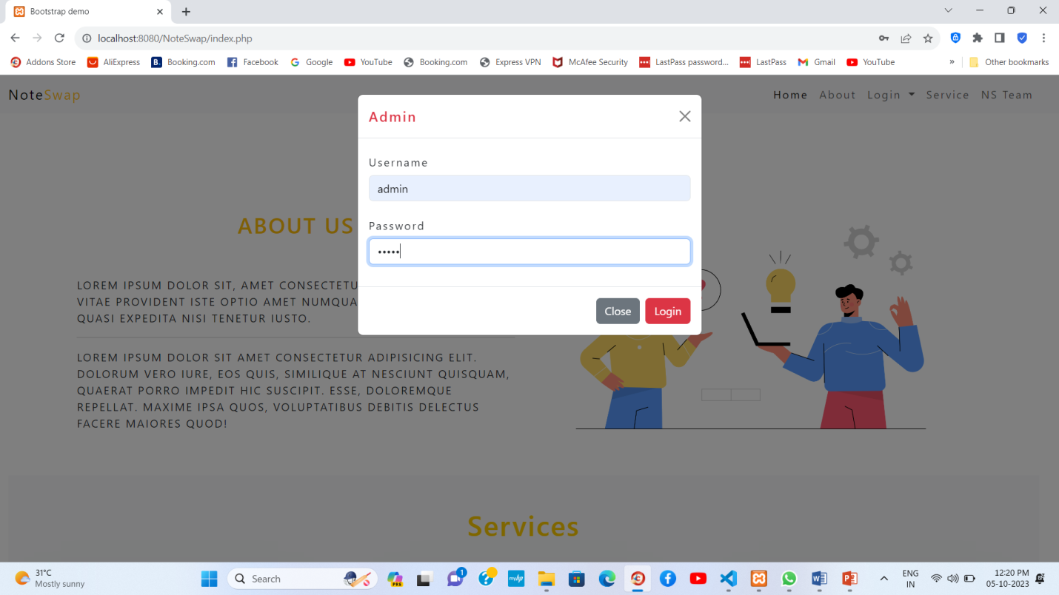 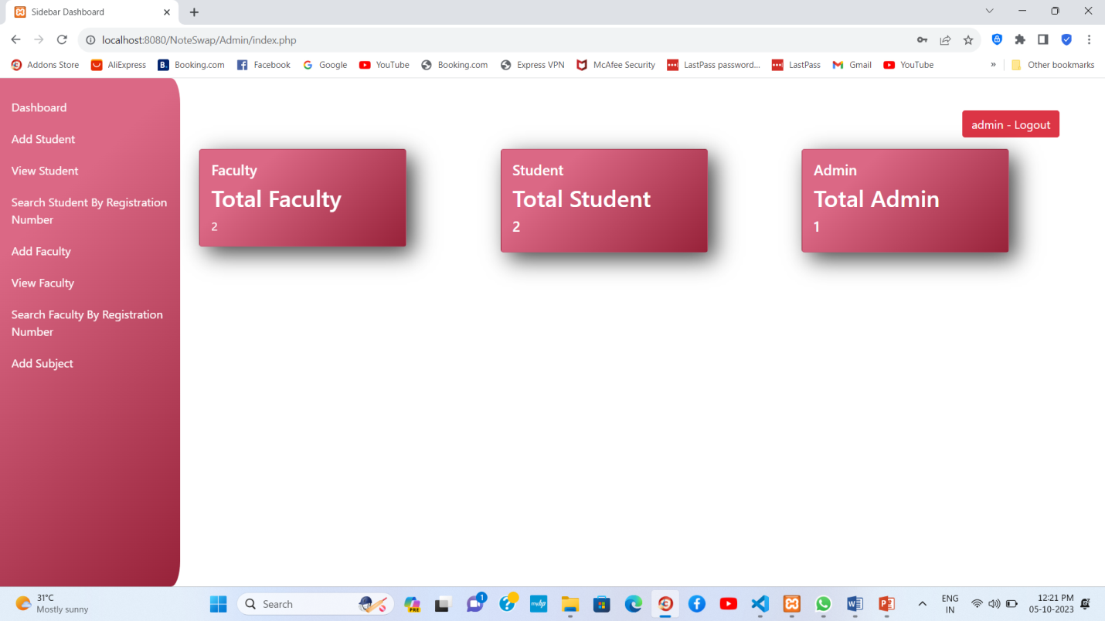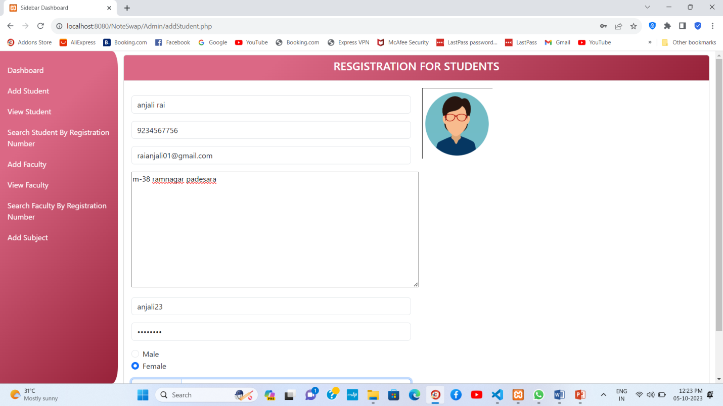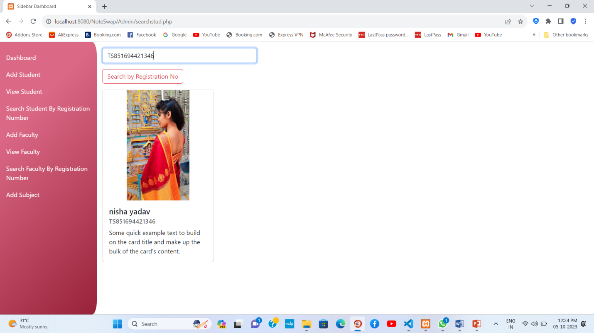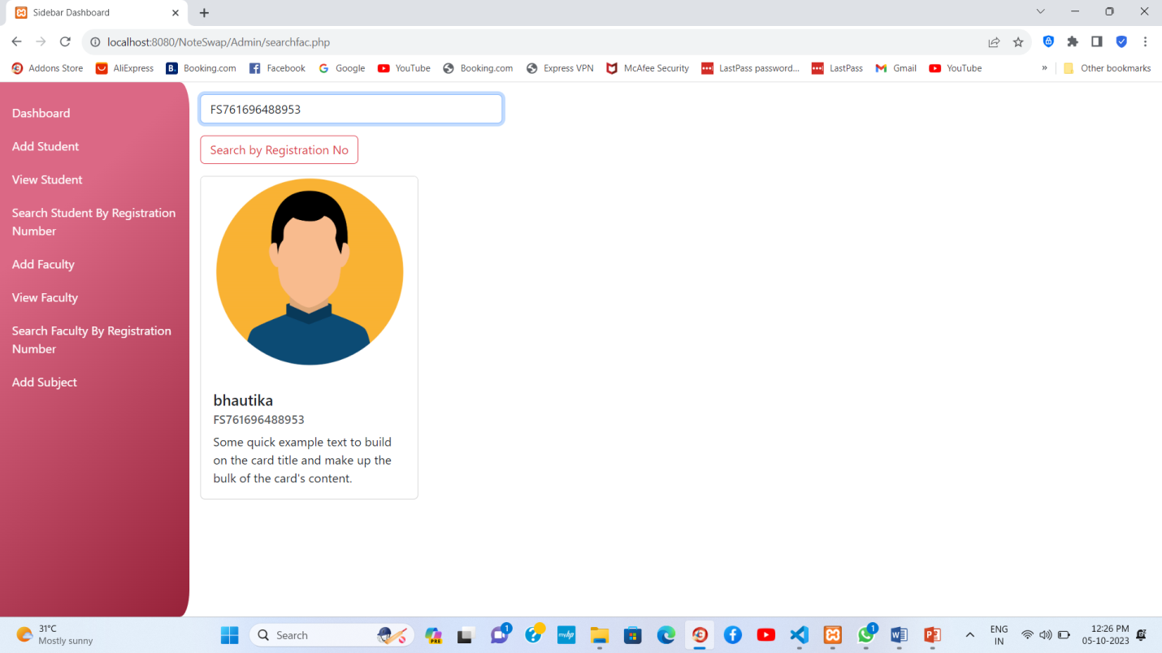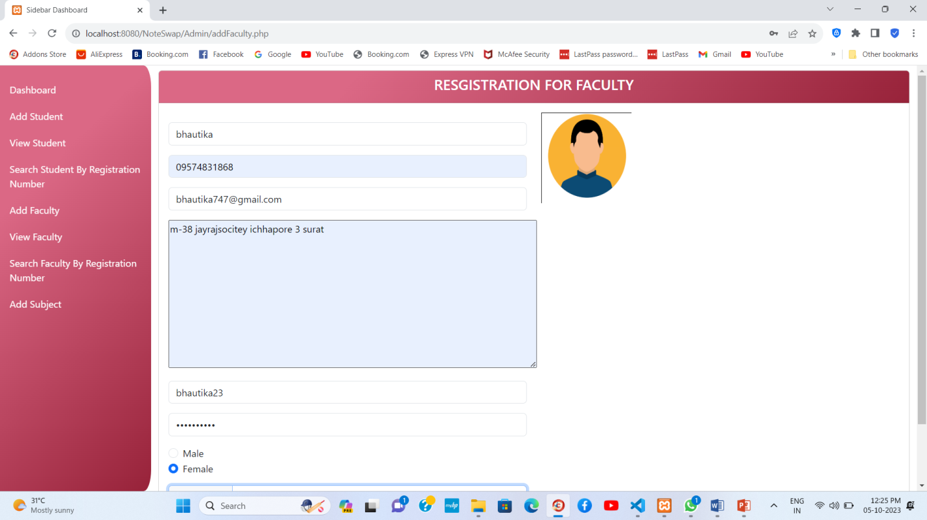

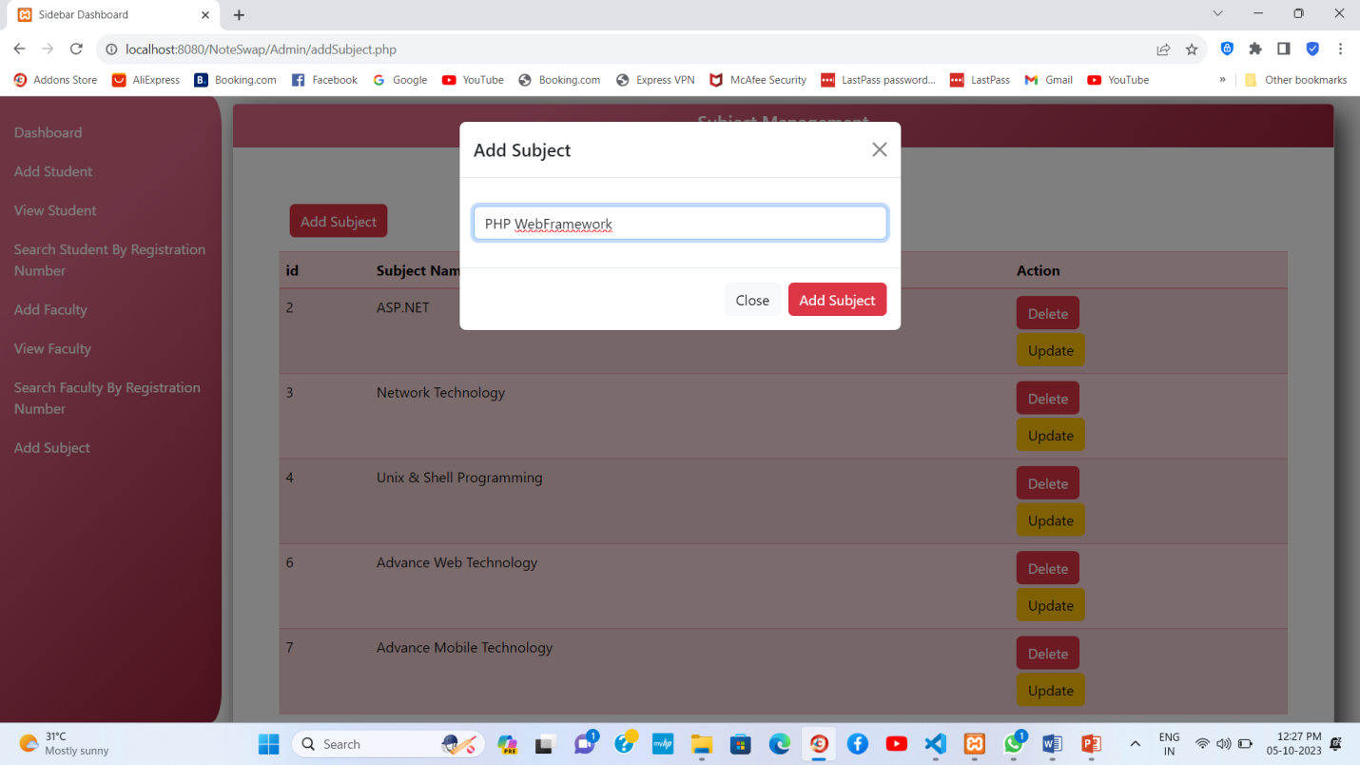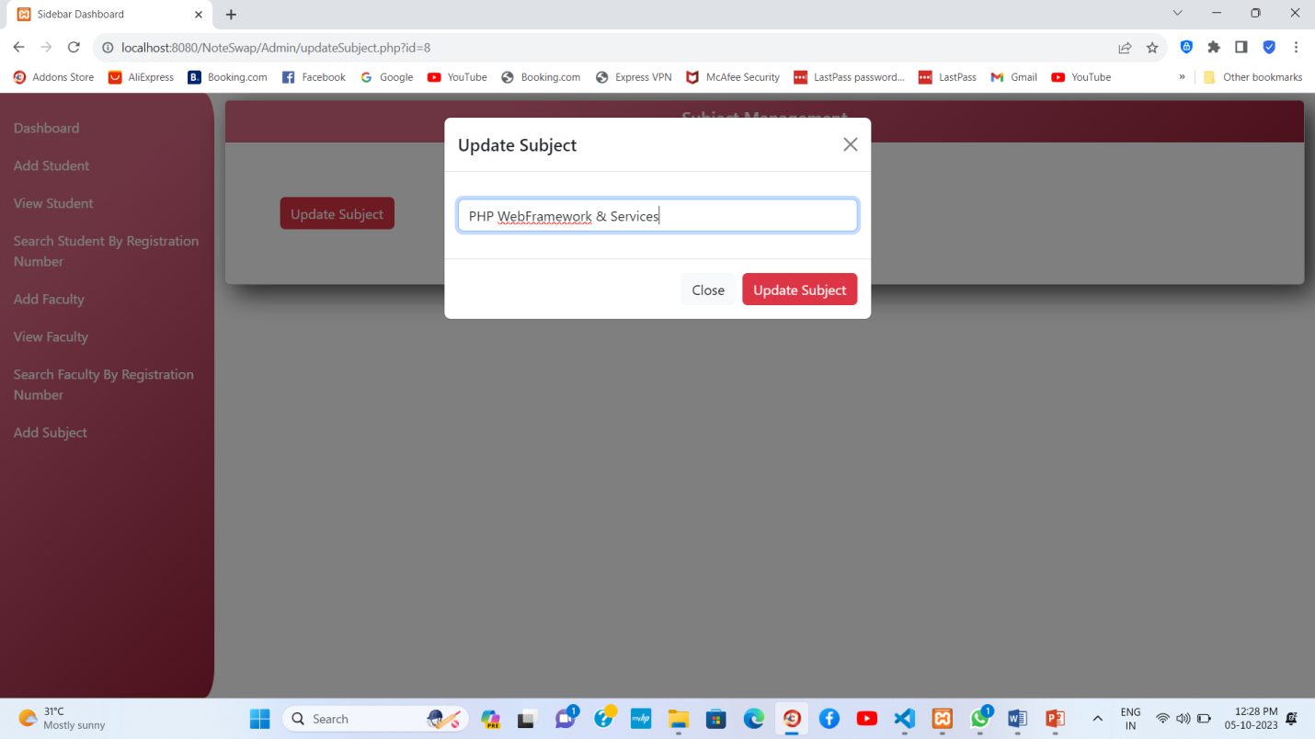

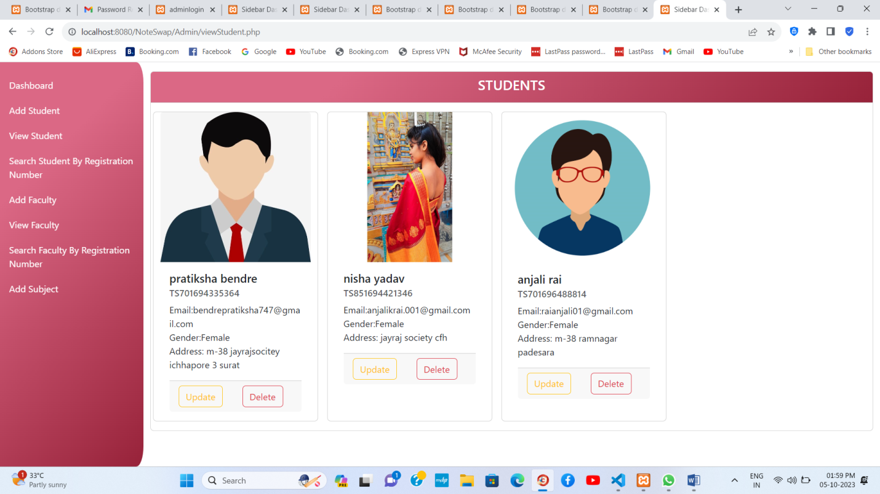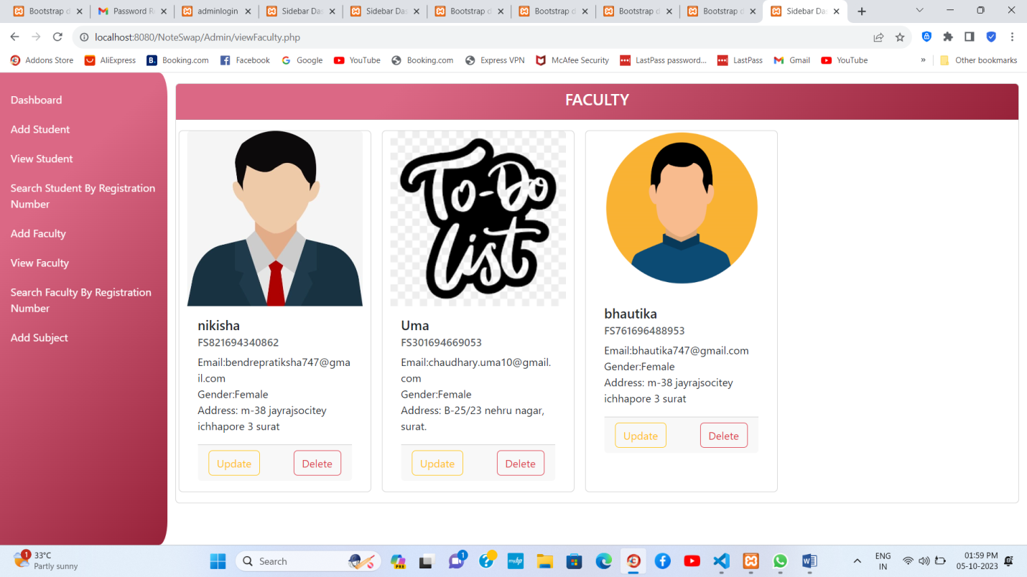

* Faculty:

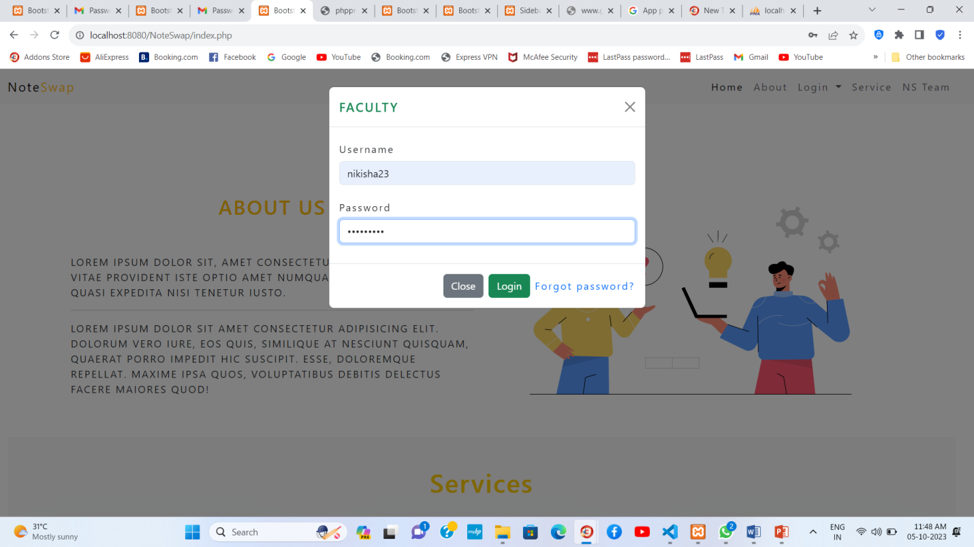 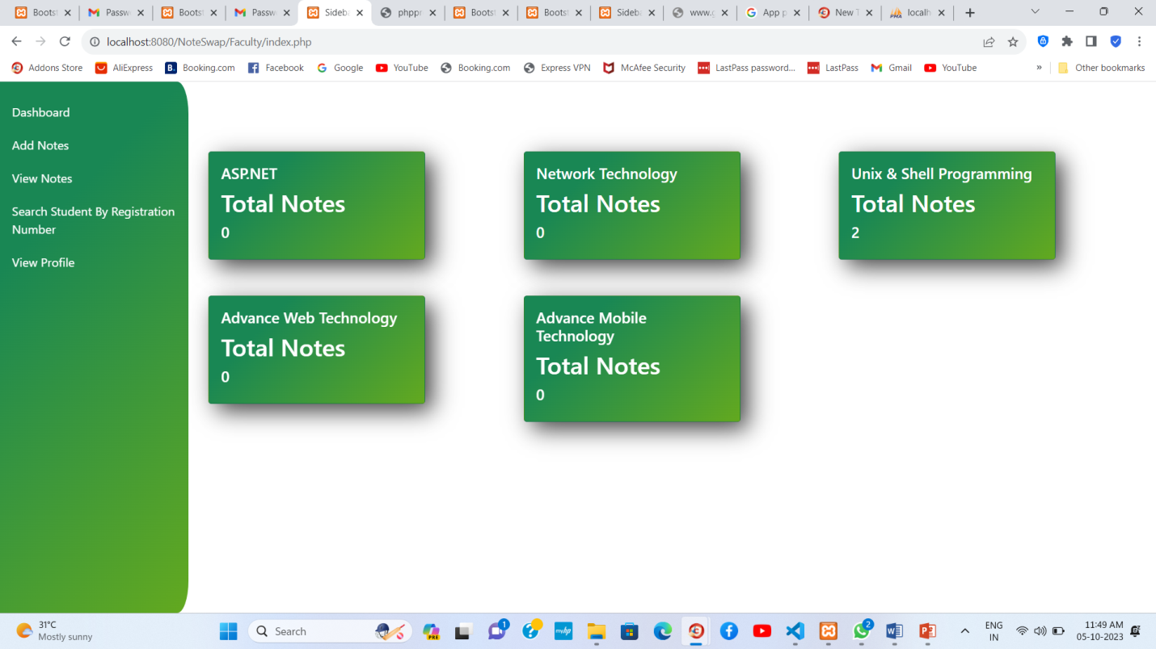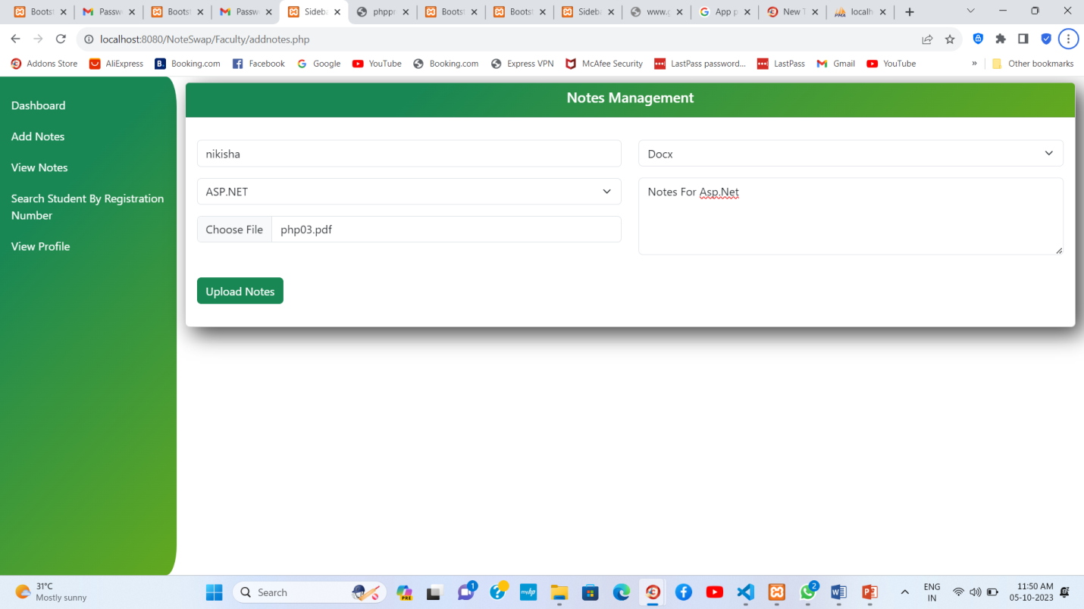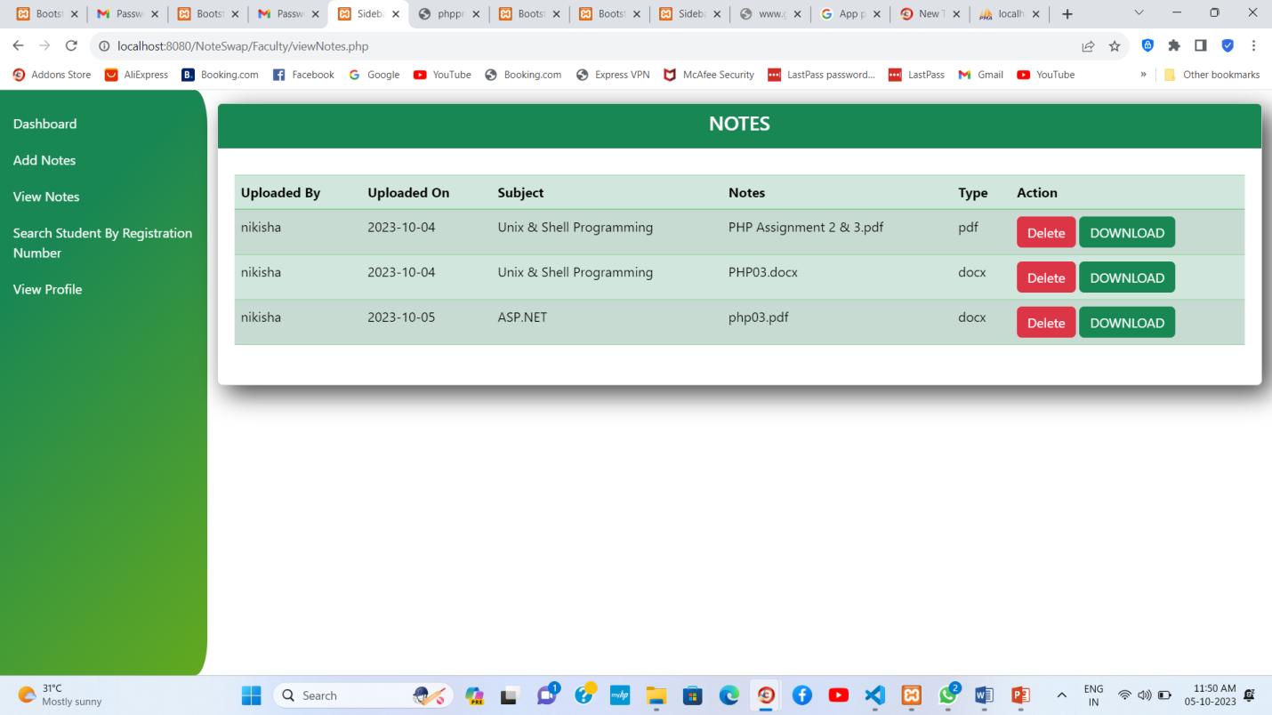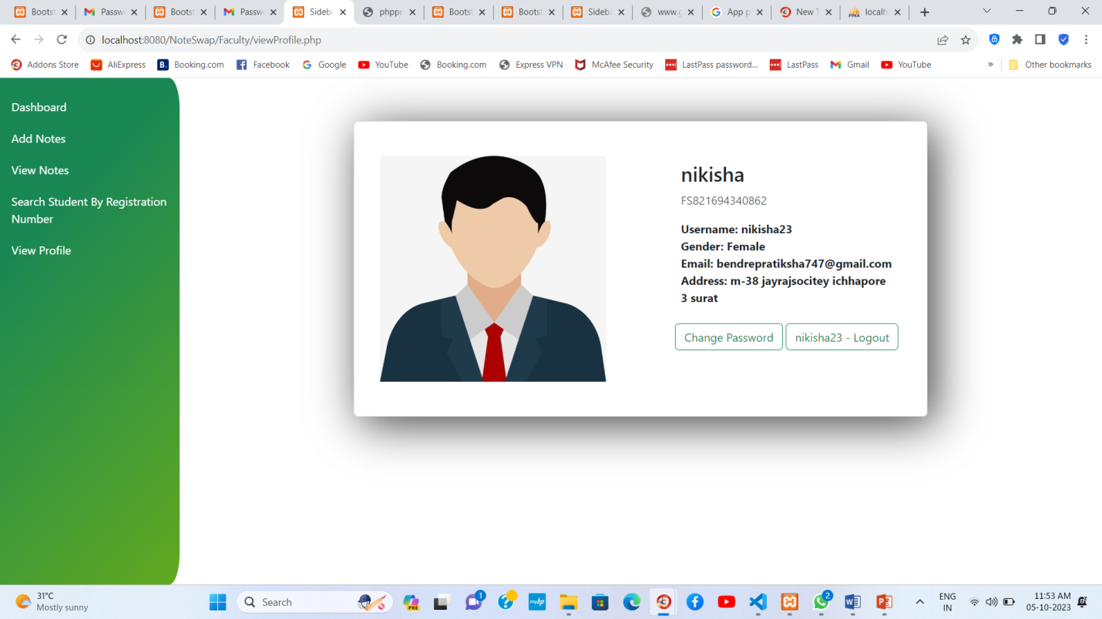

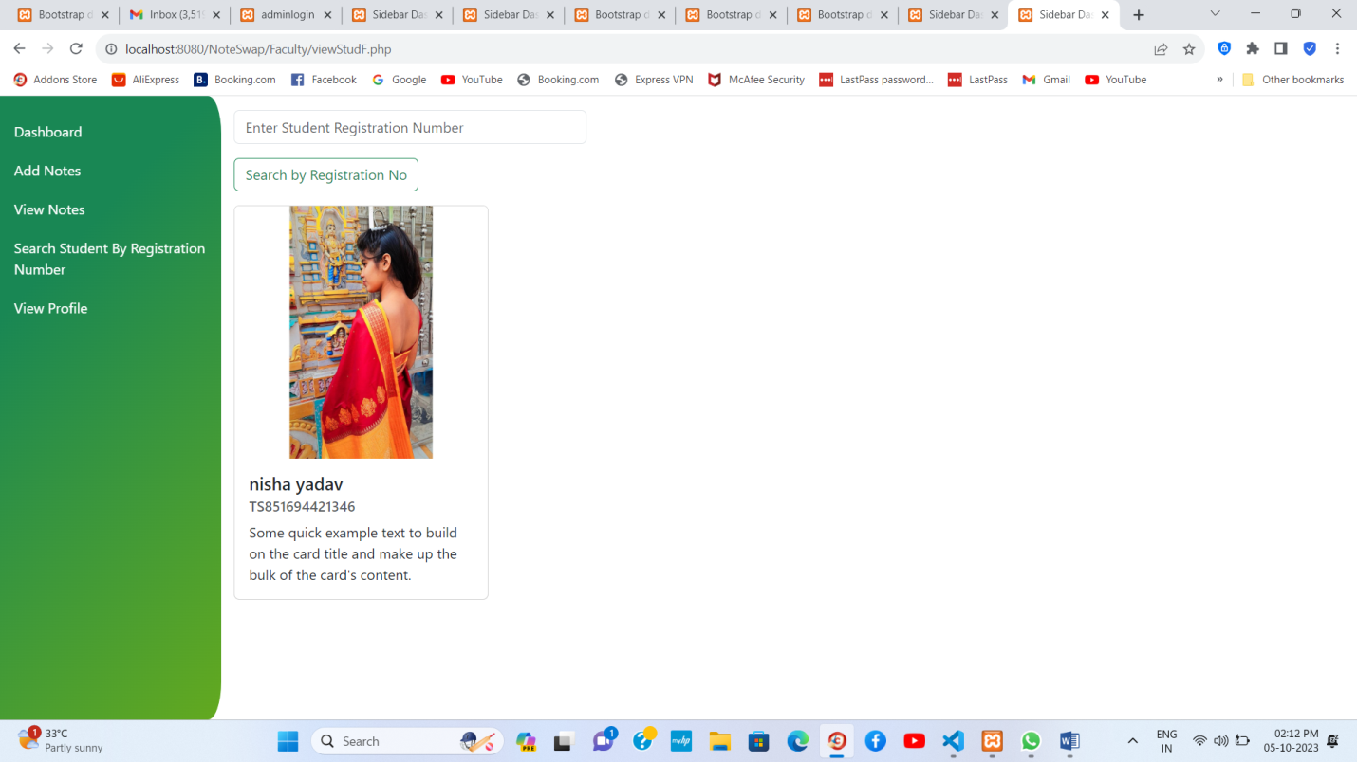

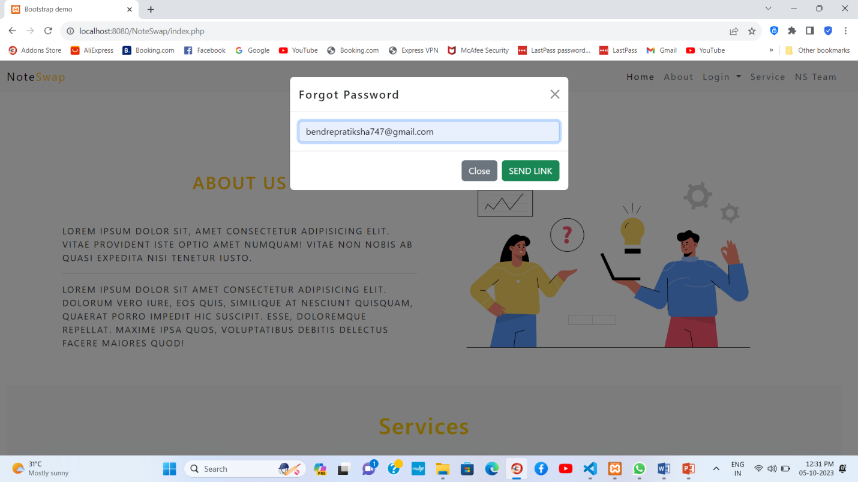

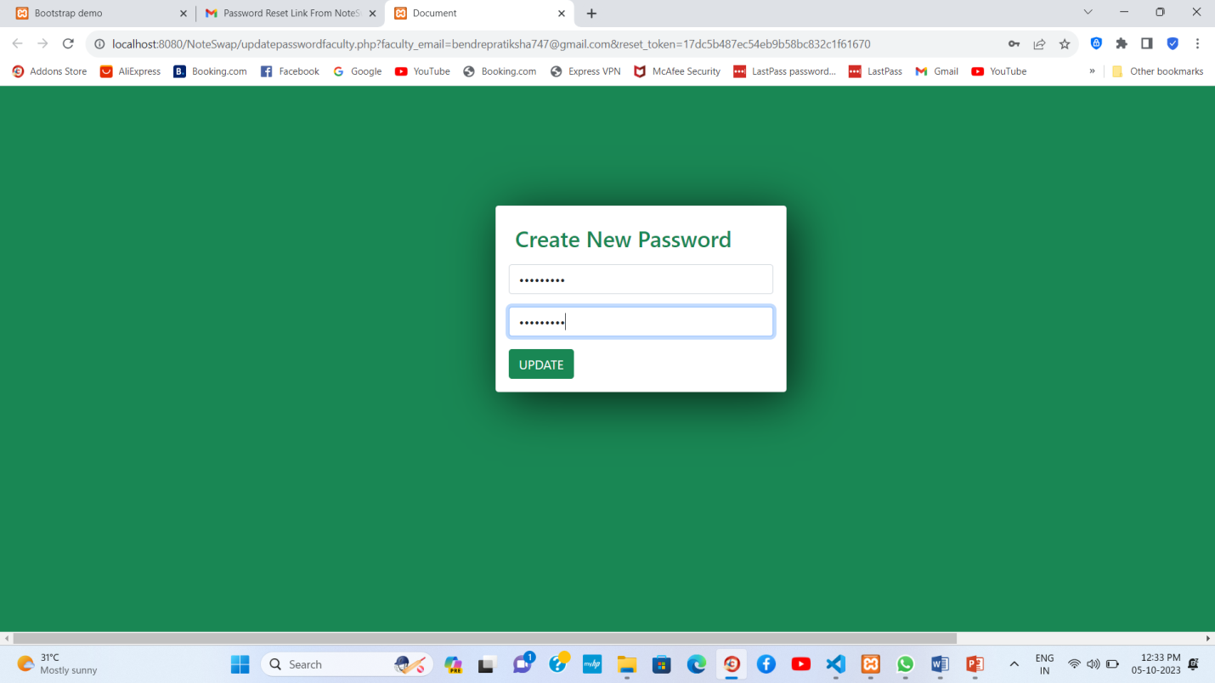

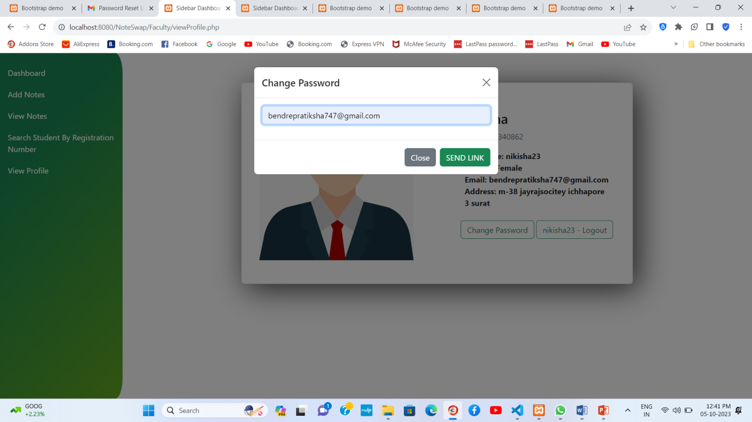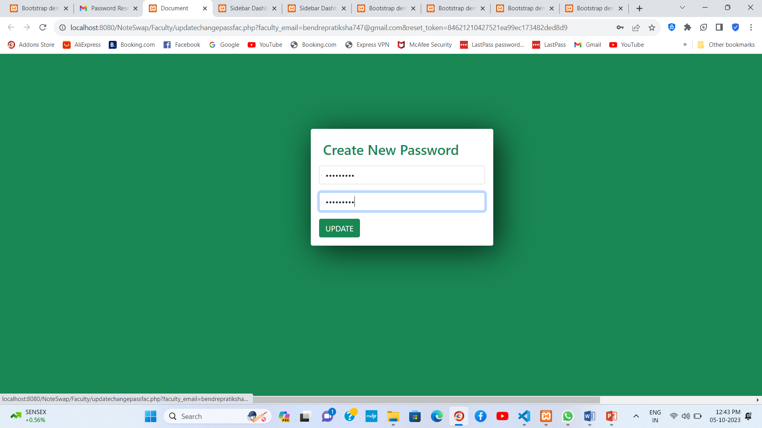

* Student:

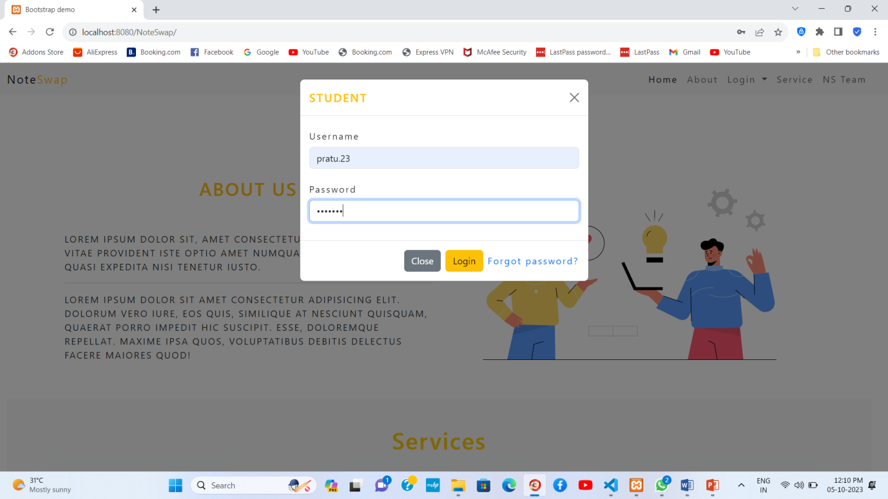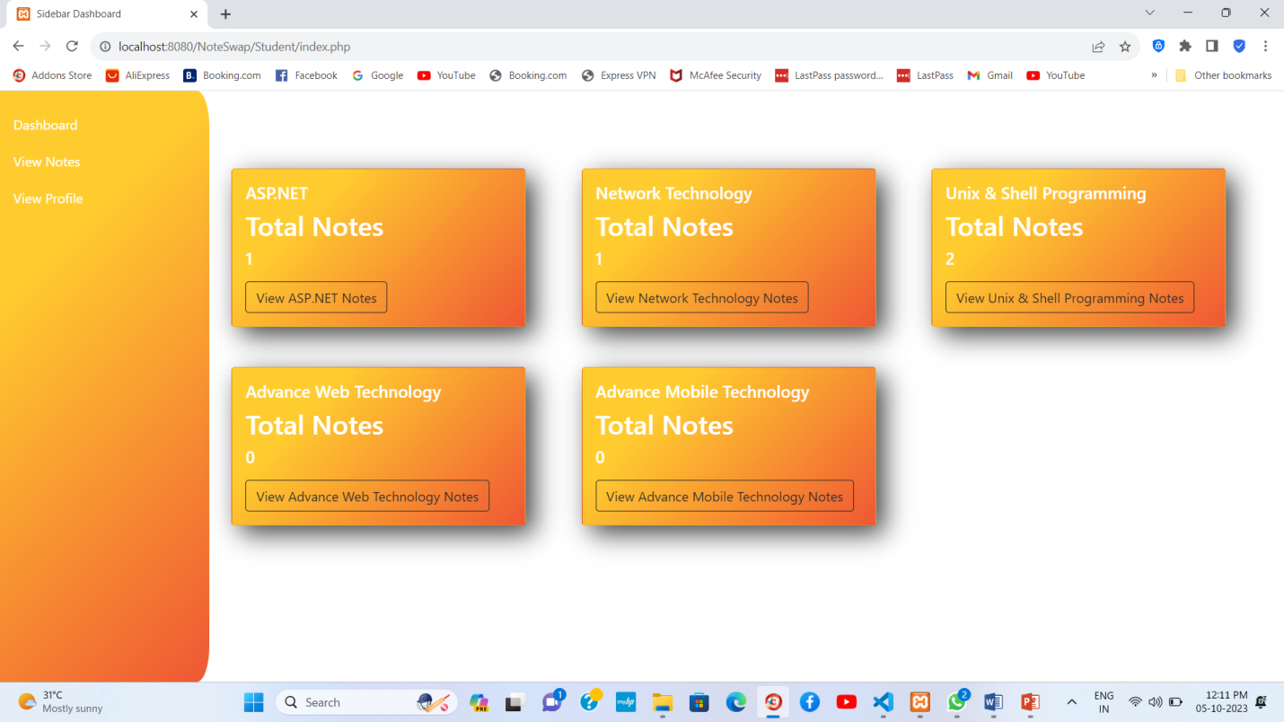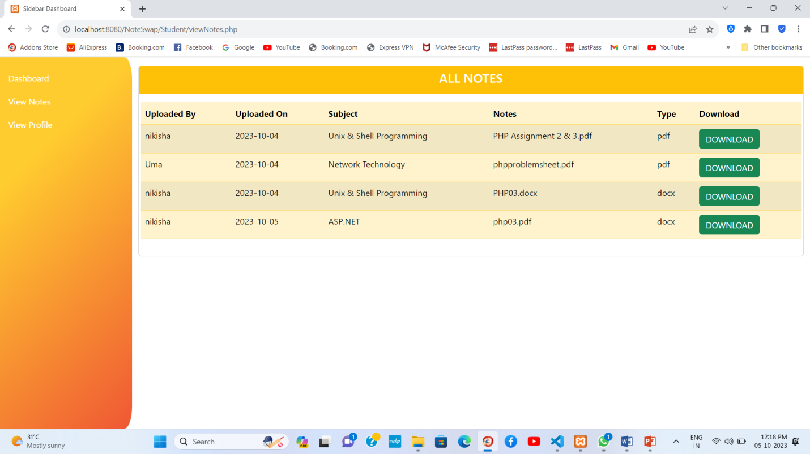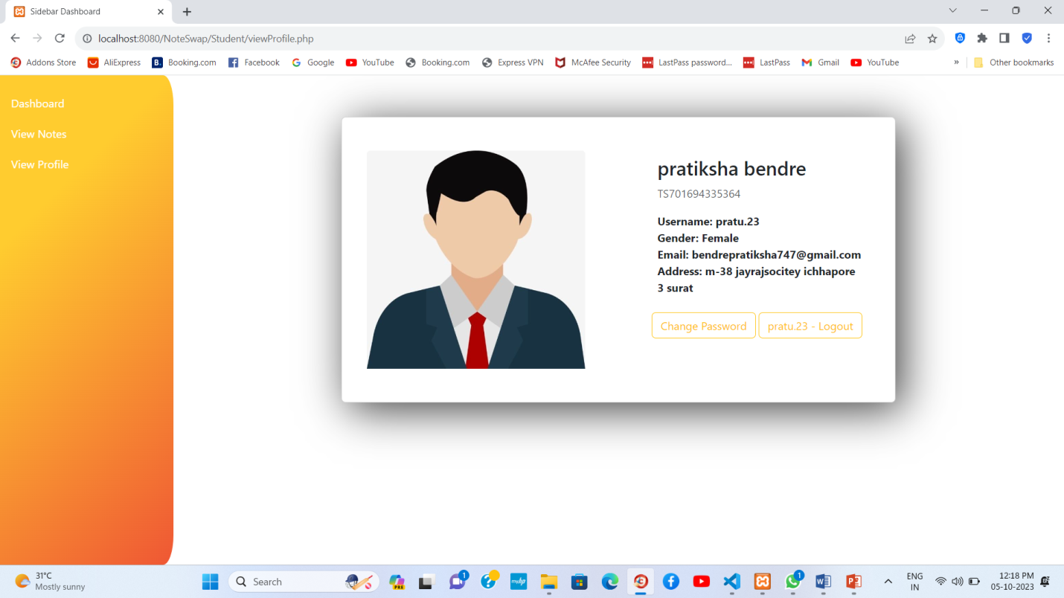

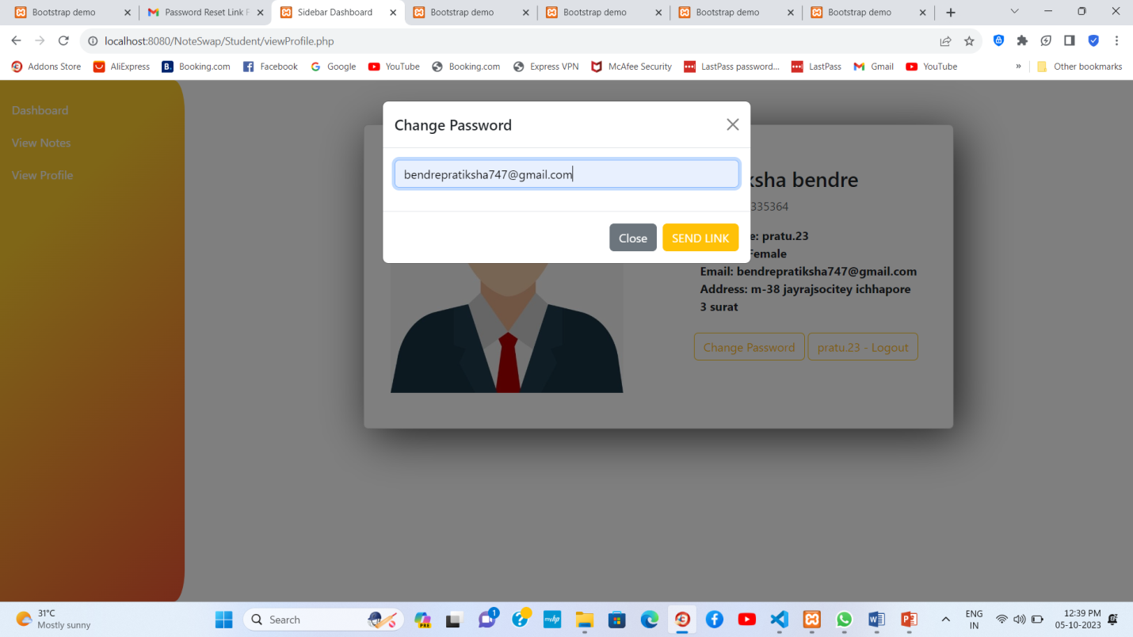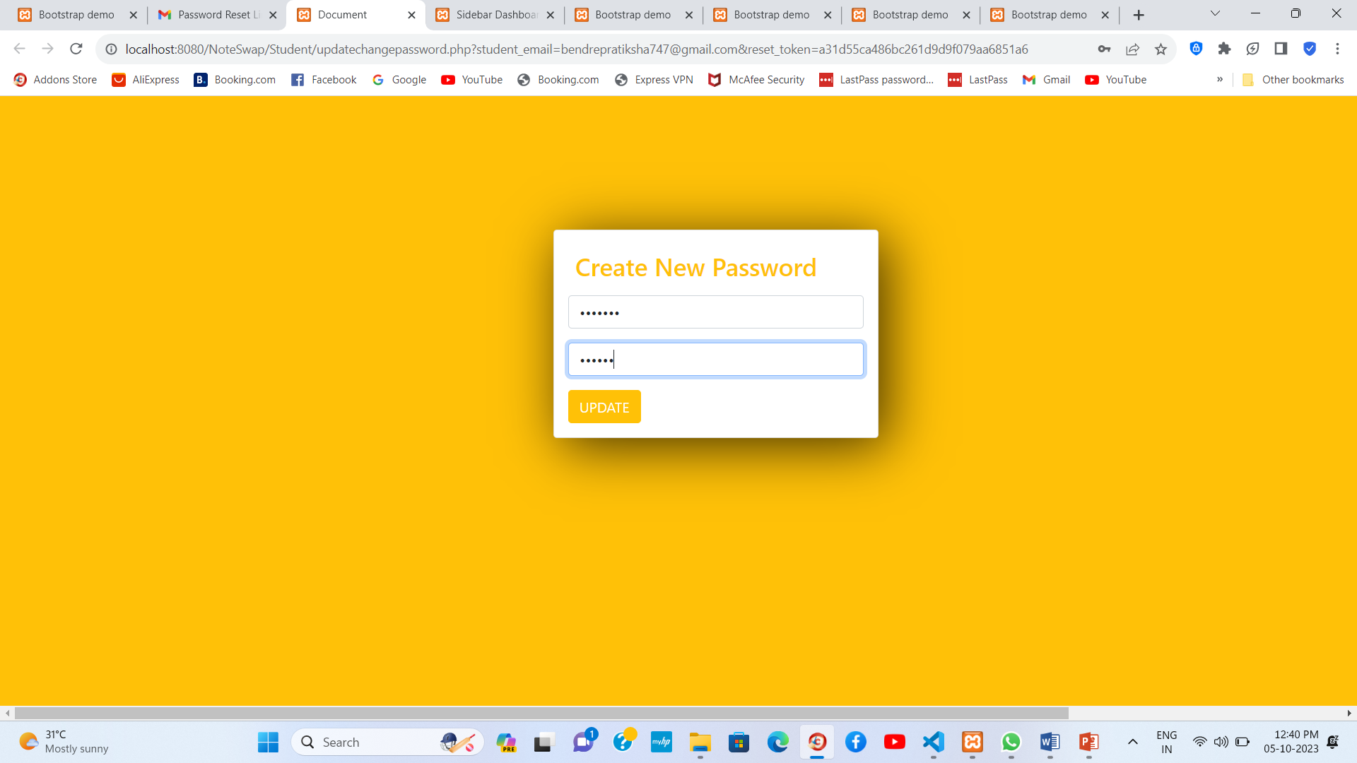

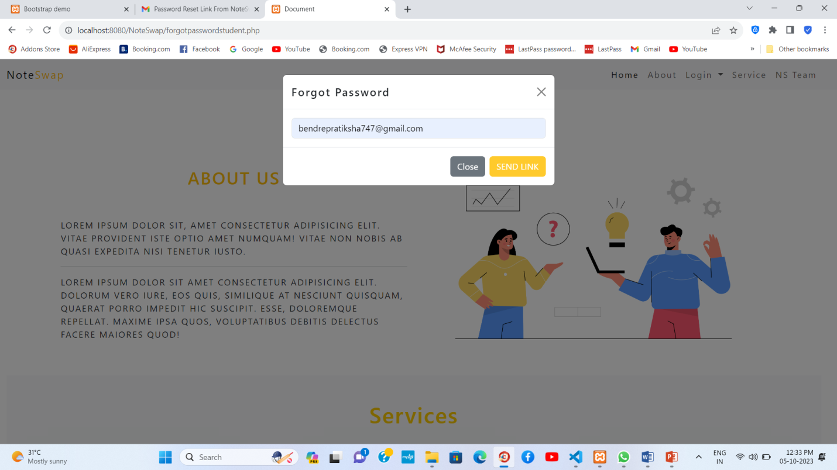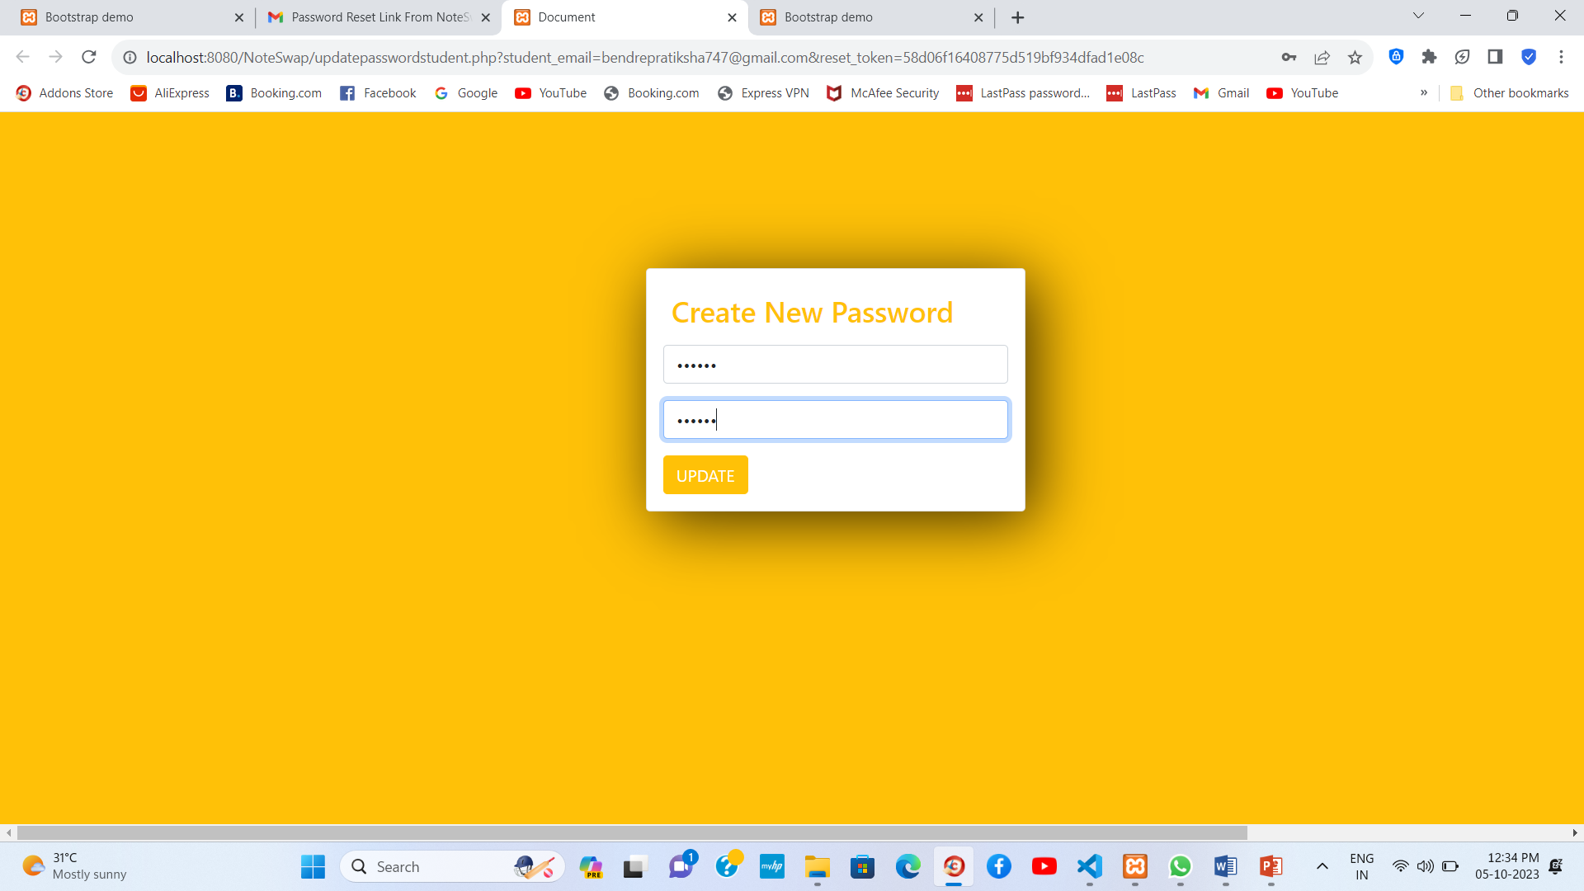

FUTURE ENHANCEMENT

* Our system is limited within our college. In future, it can be extended to university and other colleges of the city.
* This website can also convert into android application.
* We can implement the functionality like sharing posts, upload status, group doubt sessions , comment ,paid notes and upload video.
* It will be able to track their progress, set goals, and measure their study efficiency and provide users with statistics and insights about their note-taking habits.
* It can also support a discussion forum where users can post questions or engage in conversations related to not-taking, studying, or specific subjects.